Percy Pants 2015
Pants! – it’s Highway Charity

Highway-persons in underpants will be patrolling the streets of Alnwick on Red Nose Day

Heads have been turning all week to see the aerial display of underpants in Percy Terrace and South Street, Alnwick. The spectacular display of hosiery is all part of a bid by local residents to raise at least £1,500 for Comic Relief.

“Our notoriety extends all the way to No 10 Downing Street, “ says Project Director, Philip Angier. “Samantha Cameron autographed a copy of our Joke Book at a Whitehall reception on Tuesday.”

The Percy Pants Joke Book has been on sale in Alnwick all week. The charity underwear bonanza reaches a climax with a street collection on Friday 13th, Saturday 14th and Sunday 15th. Highway-persons dressed in underpants and riding hobby-horses will be challenging motorists and passers-by to empty their pockets for a good cause.

Their efforts will be encouraged by the stentorian voice of Alnwick Town Crier, John Stevens. Look out too for a personal appearance by Percy Pants himself in his lion costume.

The residents of Percy Terrace and South Street are no strangers to whacky fundraising projects. In 2013 they decorated their front doors with red noses and last year they staged a Sport Relief Sport-a-thon in the street. A hard-working team of 15 have been stitching, stringing and fundraising since January – and having many a good laugh in the process.

The team expects that generous townsfolk will surrender their cash with a laugh - “We’ve pulled up our pants, now Comic Relief needs your nickers (£££s )!!”

For further details contact:
Philip Angier
Project Director
rednose@angier-griffin.com
mobile: 07971162623
Pictures available on Dropbox – follow the link below

https://www.dropbox.com/sh/gebbj5qk2czt299/AAB_mETJy2ufXpPaNpGBqgcla?dl=0
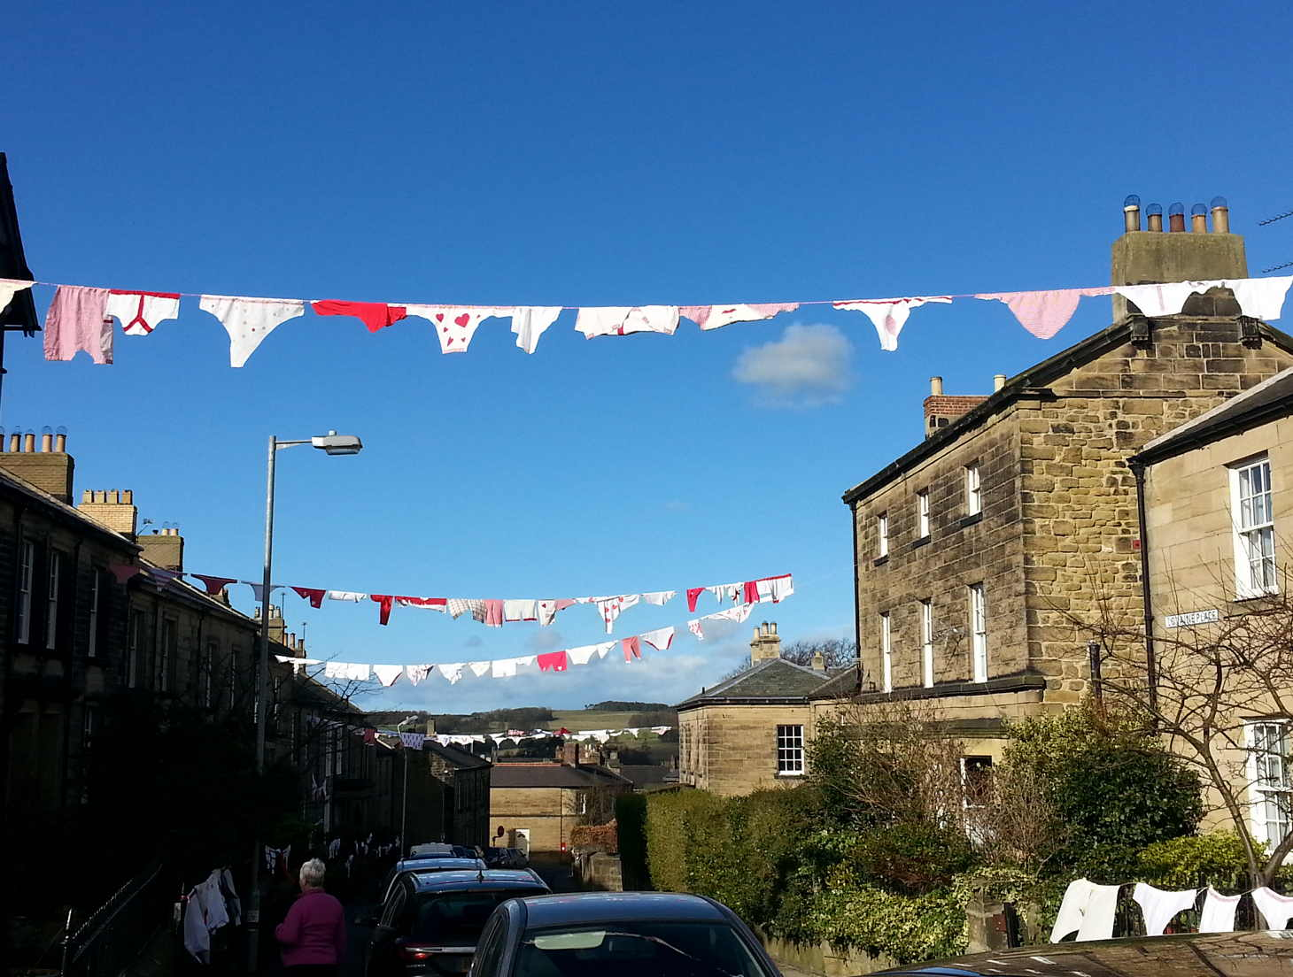
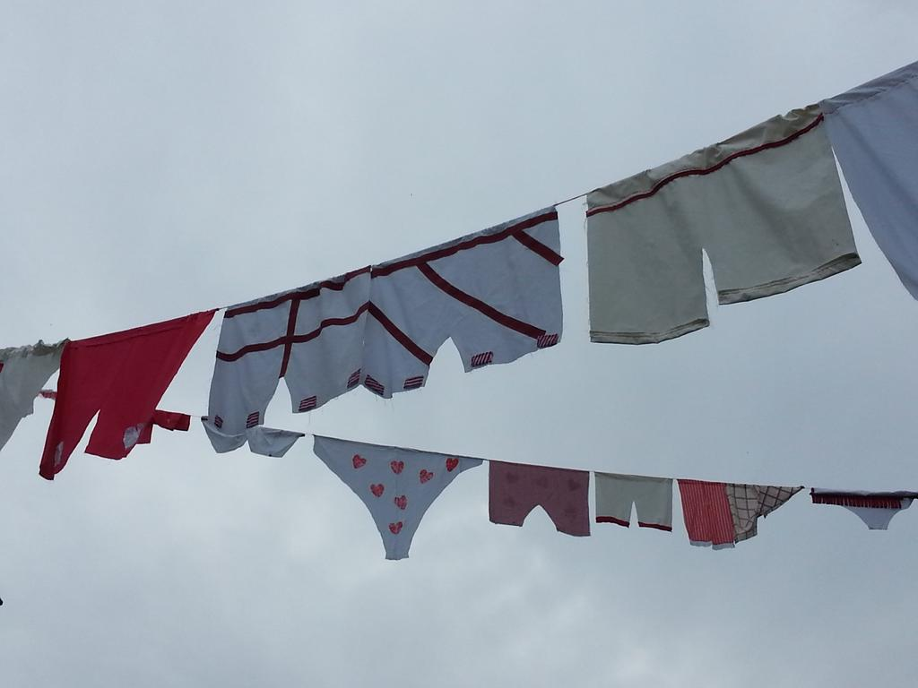

The pants are up for all to see
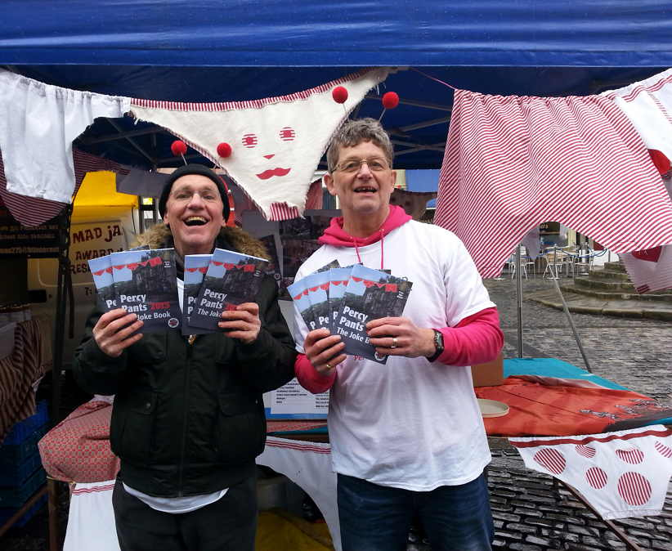
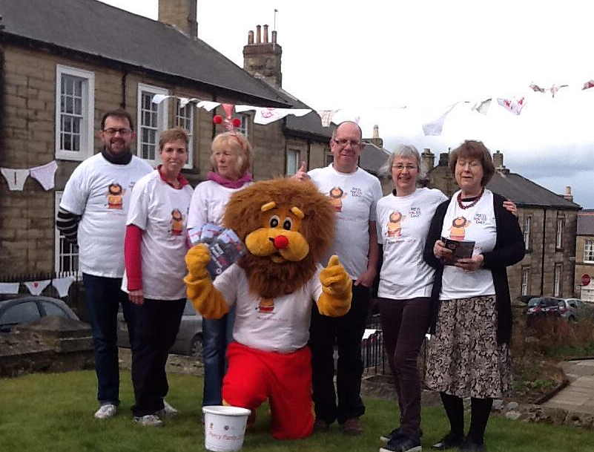

Selling Joke Books in the Market Place
Percy Lion and the team give the thumbs up
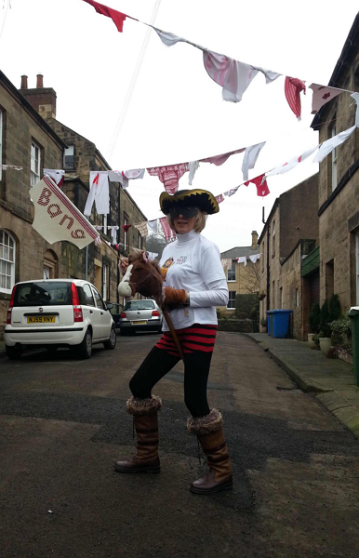

John Stevens – Town Crier Highway
Charity

Lovaine House, Percy Terrace, ALNWICK, Northumberland, NE66 1AF
@percypants2015 https://www.justgiving.com/Percy-Pants-2015/

